# SQL vs NoSQL - When to Use a SQL DBMS

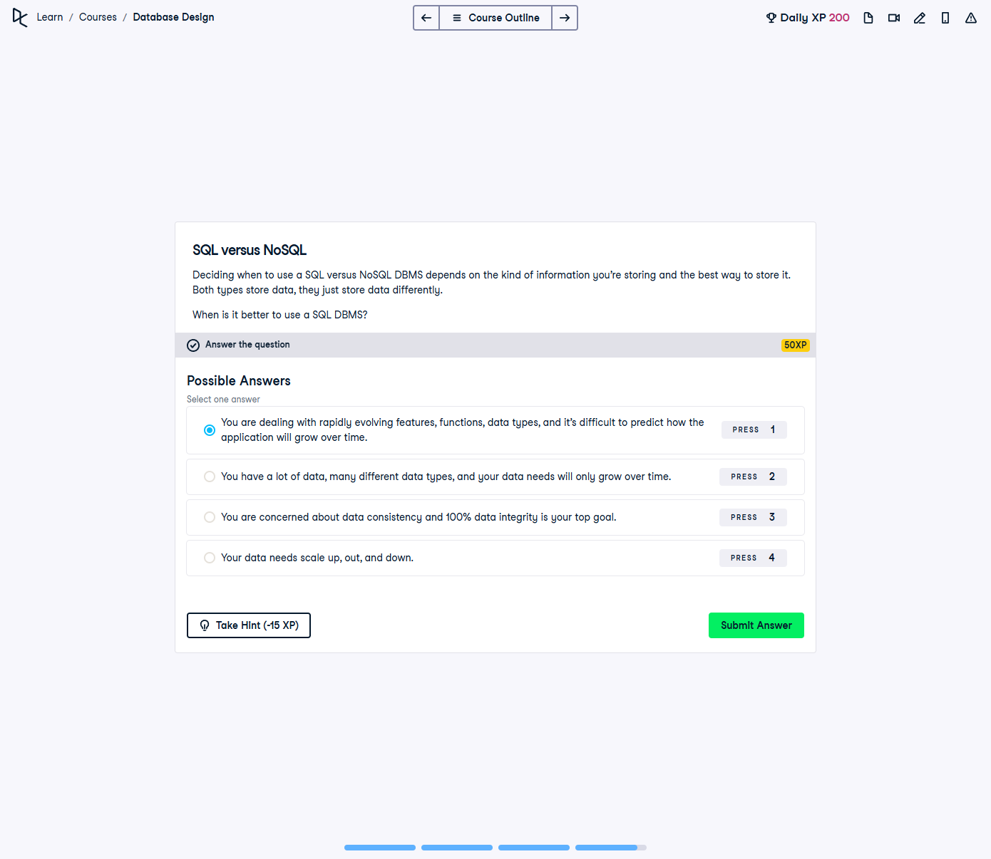

## Question:

Deciding when to use a SQL versus NoSQL DBMS depends on the kind of information you’re storing and the best way to store it. Both types store data, but they do so differently.  
  
When is it better to use a SQL DBMS?

## Possible Answers:

1. You are dealing with rapidly evolving features, functions, data types, and it’s difficult to predict how the application will grow over time.

2. You have a lot of data, many different data types, and your data needs will only grow over time.

3. You are concerned about data consistency and 100% data integrity is your top goal.

4. Your data needs scale up, out, and down.

## Correct Answer:

**You are concerned about data consistency and 100% data integrity is your top goal.**

## Explanation of the Answer:

The correct answer is **'You are concerned about data consistency and 100% data integrity is your top goal.'** SQL databases (relational databases) are best suited for applications where **data consistency, accuracy, and integrity** are critical. They use ACID (Atomicity, Consistency, Isolation, Durability) properties to ensure transactions are reliable and follow strict data rules. NoSQL databases, on the other hand, are more flexible but may sacrifice consistency for performance and scalability.